Using the Commands add-on and snippets: Step-by-step exercises
In this exercise, you will explore using the Commands add-on by looking for cmdlets related to WMI. You will then select the Invoke-WmiMethod cmdlet from the list and create new processes. Following this exercise, you will use Windows PowerShell ISE snippets to create a WMI script.
Using the Commands add-on to call WMI methods
1. Start the Windows PowerShell ISE.
2. Use the Commands add-on to search for cmdlets related to WMI.
3. Select the Invoke-WmiMethod cmdlet from the list.
4. In the class block, add the WMI class name Win32_Process.
5. In the name block, enter the method name create.
6. In the argument list, enter notepad.

Insert picture of add-on window
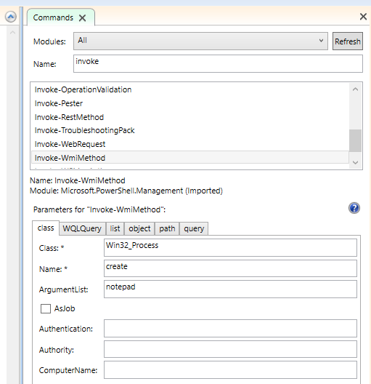

7. Click the Run button. In the output console, you should get the following command, and on the next line the output from the command.
Insert picture of command and results
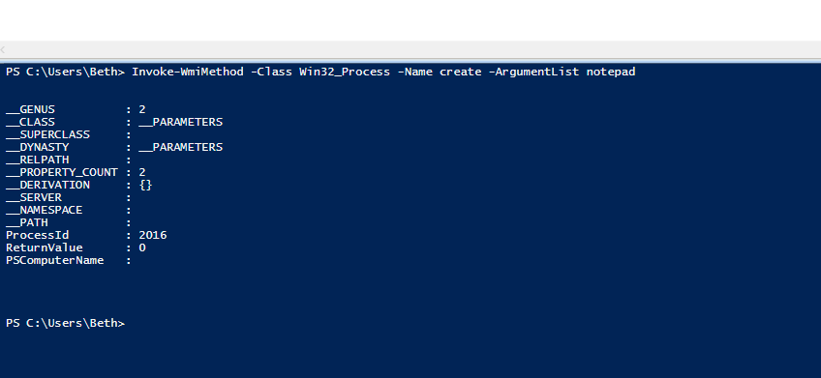

8. Modify the ArgumentList block by adding calc to the argument list. Use a semicolon to separate the arguments, as shown here.
Notepad; calc
9. Click the Run button a second time to execute the revised command.
Executing the previous command called to open both Notepad and Calc.exe
describe what happened?
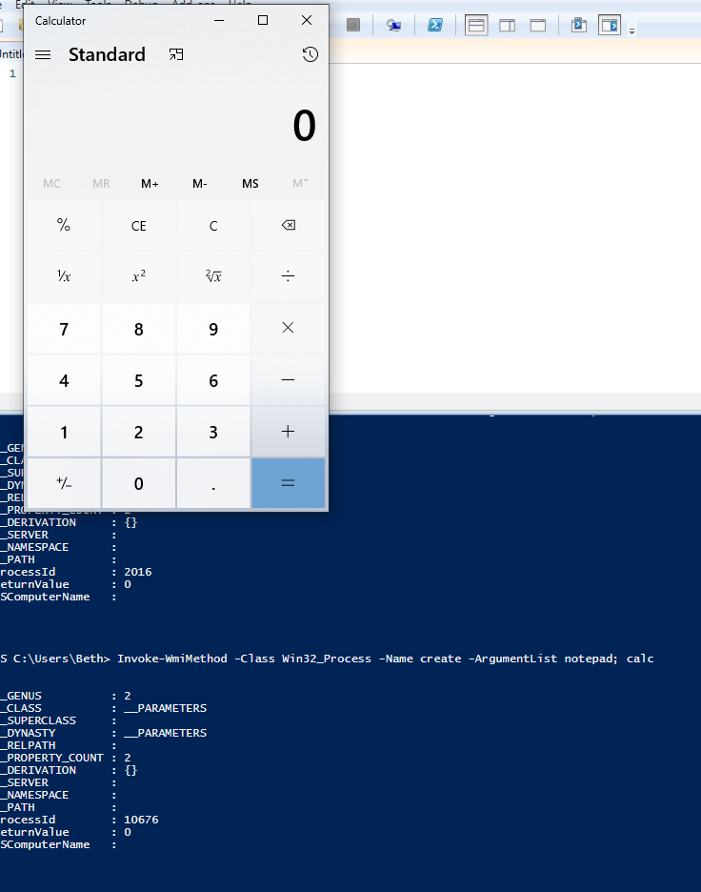

10. In the Commands add-on, look for cmdlets with the word process in the name. Select the Stop-Process cmdlet from the list of cmdlets.
11. Choose the name parameter set in the parameters for Stop-Process block.
Insert picture of add-on window
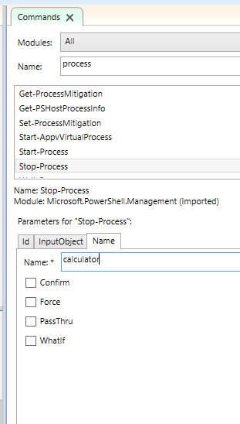
Note
On Windows 10, calc launches calculator.exe. You will need to substitute calculator for calc on Windows 10.

12. In the Name box, enter notepad and calc.

13. Click the Run button to execute the command.
Describe what happened?
The Stop-Process command was passed an array of [string] names, and stopped each process
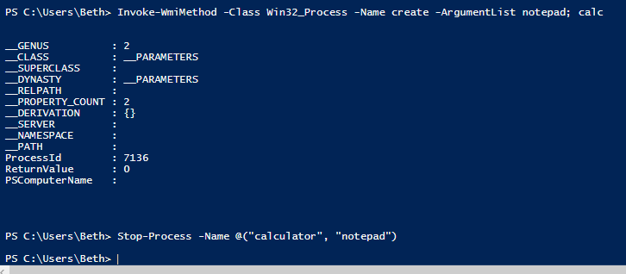
14. Under the name block showing the process-related cmdlets, choose the Get-Process cmdlet.
15. In the name parameter set, enter calc, notepad.
16. Click the Run button to execute the command.
Insert picture of command and results
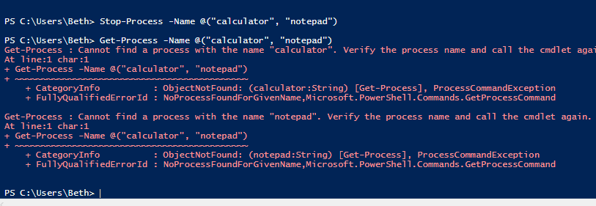
This concludes the exercise.

